DFD Diagrams:
Context Level (0th Level) Diagram:

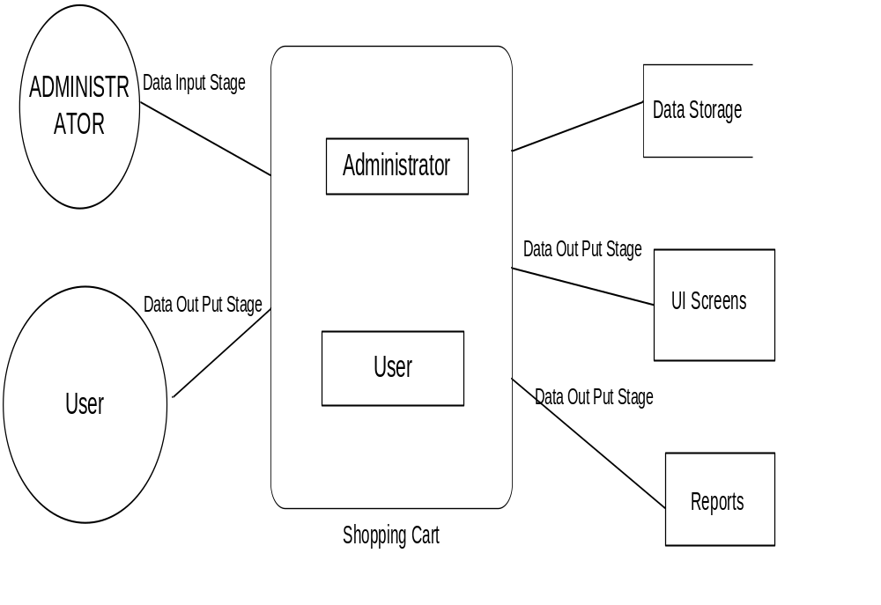

Login DFD
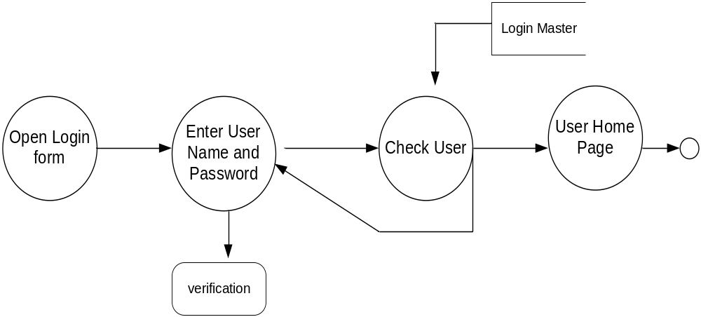
Admin Details Data Flow:
1st Level DFD Diagram:

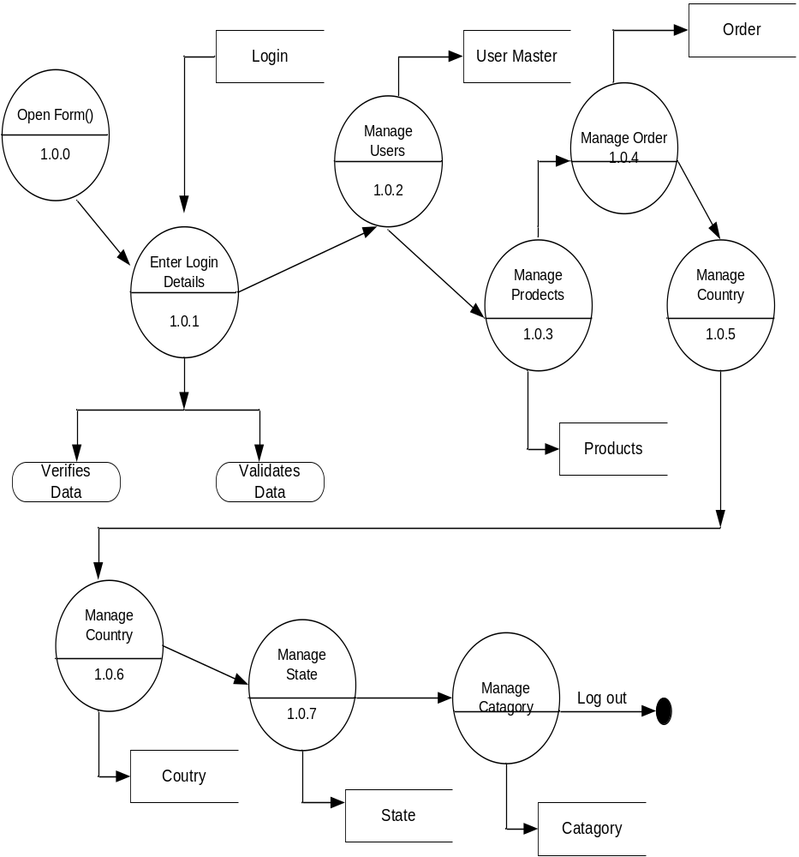

2nd Level DFD For Manage Product
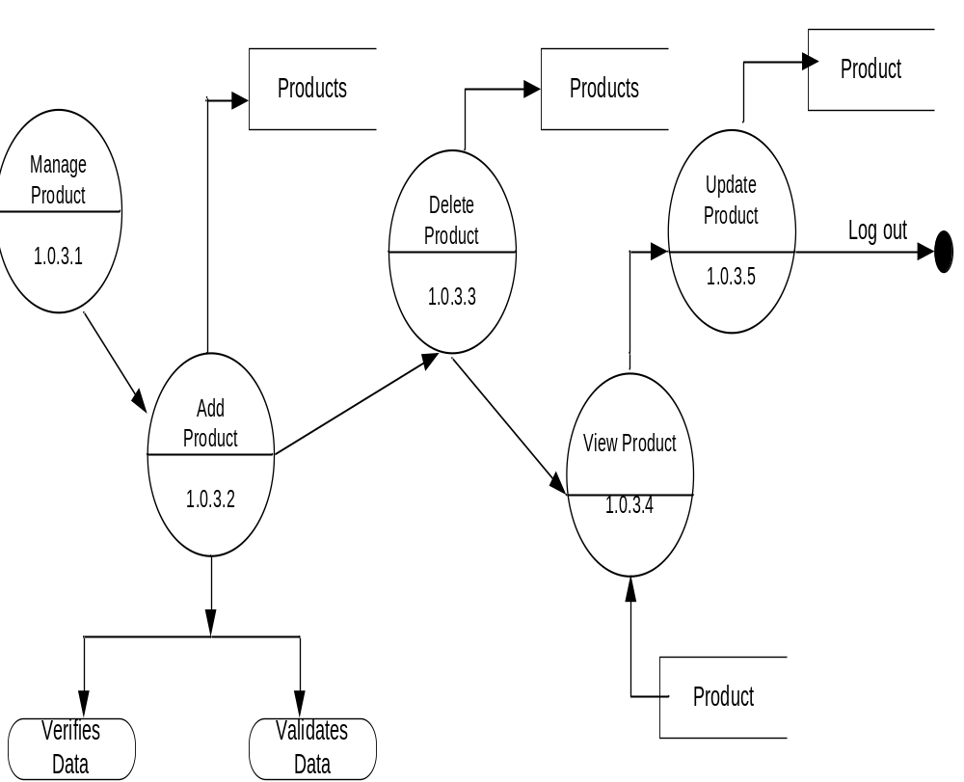

2nd Level DFD For Manage Orders

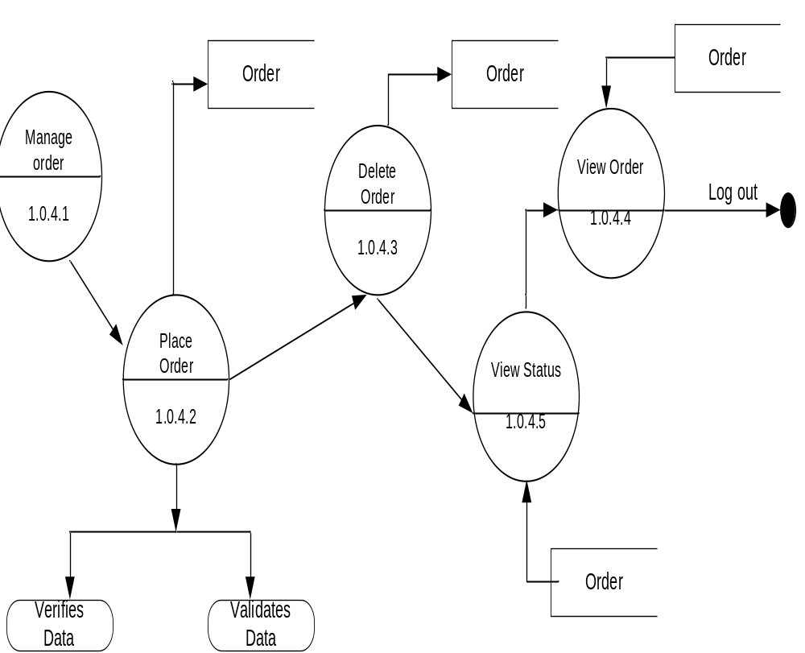

User Activities DFD

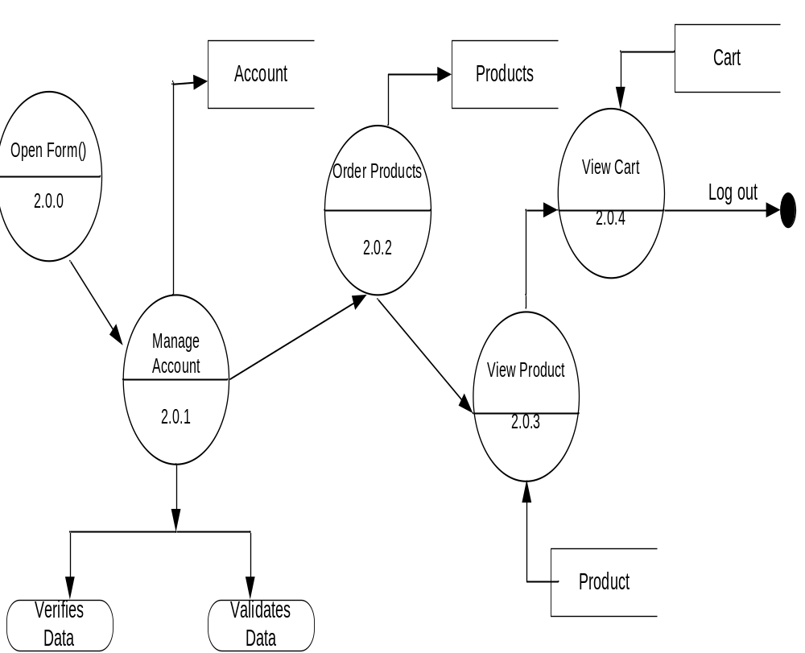

DFD for new user registration
